How to upload a user bulk load file through PASS
Bulk File PASS administrators can upload a user bulk load file directly from the Bulk load history page.
To do this, from the PASS menu, select the option: Bulk load history.

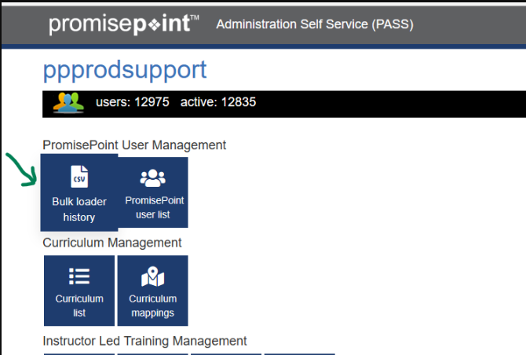
Then, click the Upload a Bulk File button:
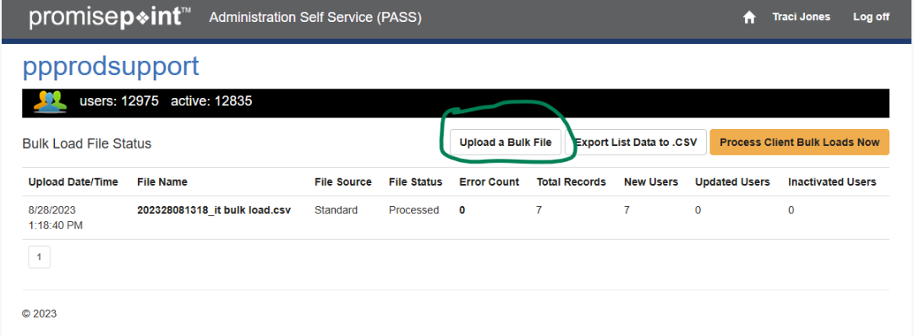

To select your bulk file, click the Choose File button:
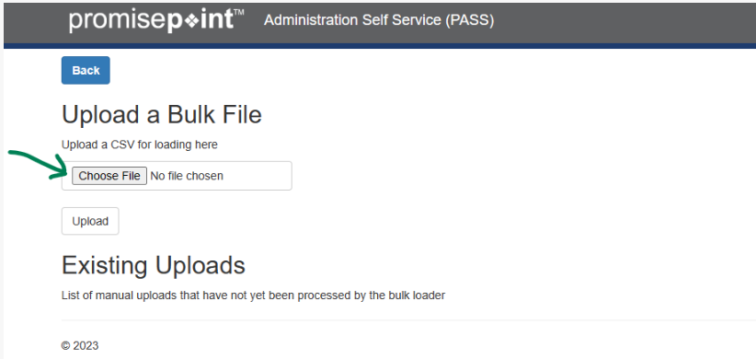
This will open a window where you can browse to find and select your bulk file:
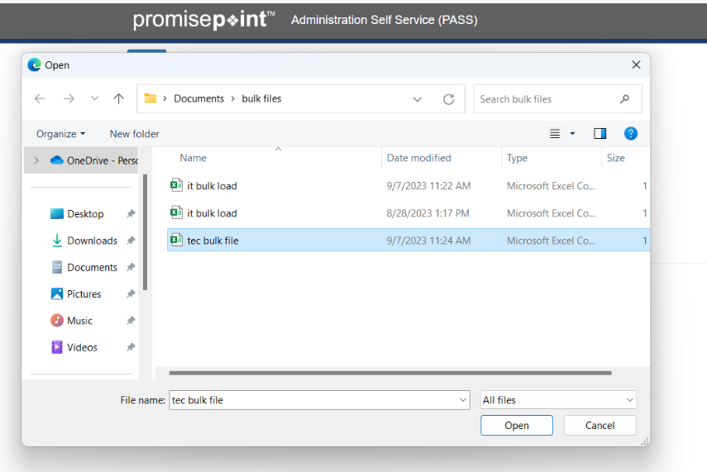
Then click the upload button to upload the file:
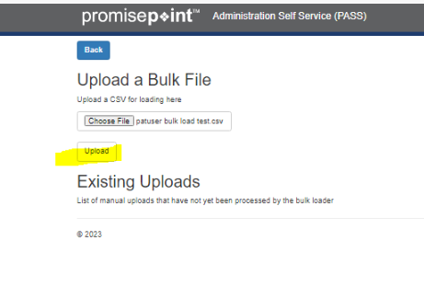
The file is uploaded; other bulk files may be added too to run more than 1 file.
The bulk file can be processed by our automated times, or it can be launched immediately.
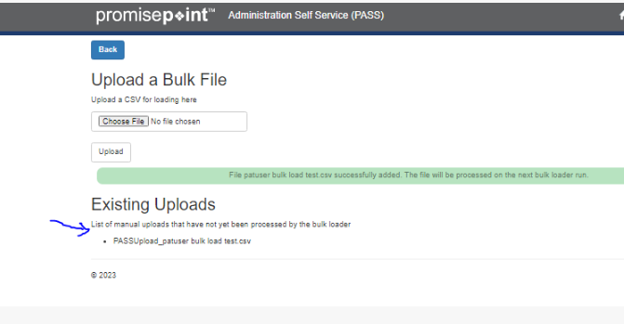

To run the file/s now, select the Back button:
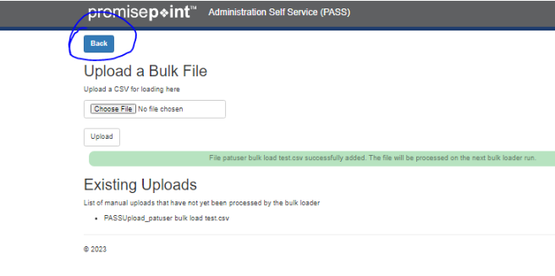
Then from the bulk load page select the Process Client Bulk Loads Now:
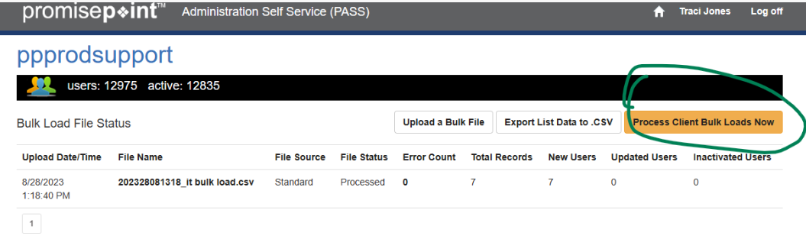
Then click Run bulk loader for this client now:
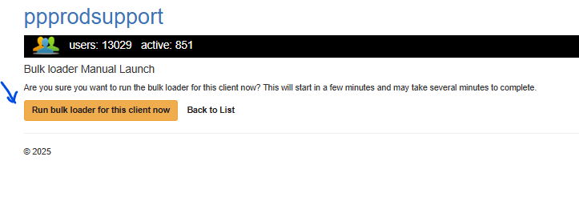
You can tell the file was uploaded through PASS if the file source reads Direct Load:
